Core|WFM: Time Management

Contents
Document Version Control 1
Approved process for raising 2
Consultation & Approval 2
Change Management 2
How to 3
Testing 5
Communications 5
Downstream Systems & Processes 5
Affected Reports 5
Additional Background Information 6

Document Version Control
Change History/Review Details
Date | Version | Review by | Summary of Change
Mar22 | 1.0 | HC | Created

Approved process for raising
Does the change need to be raised through a particular route or by a particular person/team? Are there any actions which need to be taken or considered prior to processing in the HRIS Support Centre?
A request for change could come from any source and is most likely to be a business requirement due to changes in existing process or implementation of new processes.
Alternatively it could be a fix or enhancement that has been provided by the supplier.
Any changes to any area of the Portal must follow the Change Management process in force at the time of the change.
Changes may need to be presented at HRSEG for agreement before being implemented and possibly shared with the CoreTime POG.

Consultation & Approval
Who is the owner of this information? Who needs to be consulted about this change before you begin work on it? Does anyone need to approve this change before it is implemented?
Changes may need to be presented at HRSEG for agreement before being implemented and possibly shared with the CoreTime POG.
A change may need payroll approval if it relates to Timesheets.

Change Management
What type of change is this? When should approval be sought and from whom (internal to team or change manager)? Who would normally be responsible for implementing?
The system changes must be approved by the System Owner (the Head HR Systems) or their nominated deputy, via the change request in OSM, ideally before implementation

How to
Technically how to process the change in the system
Adding a new ….
As there are multiple areas within Time Management please refer to the relevant 'How To' guide.
HOW TO - Create Reason Codes and Reason Code Groups
HOW TO - Maintain Pay Codes for Time Management
HOW TO – Create a Pay Code Group in WFM
Changing a ….
As there are multiple areas within Time Management please refer to the relevant 'How To' guide.
HOW TO - Maintain Pay Codes for Time Management
HOW TO – Create a Pay Code Group in WFM
Removing a ….
As there are multiple areas within Time Management please refer to the relevant 'How To' guide.
HOW TO - Maintain Pay Codes for Time Management
HOW TO – Create a Pay Code Group in WFM
Standard Icons & Terminology
Standard Button Names  Enter Query Mode button:  Previous Record button:   Previous Section button:   Save button:   Insert Record button:  | Execute Query button:   Next Record button:   Next Section button:   LOV button:   Delete Record button:  | Cancel Query button: 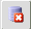  Red Door button:   Duplicate Record button: 
Navigation Paths
Show the final navigation path option in bold+italics, for example;
Core|Personnel > Reference > Reference A – C > Accident Codes
Core|Pay > Reference > Pay Groups
Any further navigation beyond the navigation path can be added after an ellipsis (…), for example;
Event Management > Event Configuration … HR Events > Change of Address
Other Standard Terminology

Testing
Who would normally be responsible for testing? Are there standard items to test?
The Functional Analyst team will usually be responsible for testing any changes.
The changes should be made in a suitable test environment and may need to be tested for different user access roles depending upon the nature of the change. For example changes made to items accessed by departmental users should be tested using the relevant menu profile(s) assigned to those users

Communications
Who needs to be informed (but not consulted) about this change? Detail when they should be informed (before or after the change).
Departmental users should be informed about changes via the HRIS bulletin, ideally before the changes are made.
HR Systems support should be informed when the changes are made.
Business Change and Training will need to be informed before the change is made as guidance and web pages may need to be updated and we may wish to send communications to employees if the change directly affects them.

Downstream Systems & Processes
Details of any processes which are affected or need to be carried out following, or as part of, the change. Please detail any triggers, actions required and when the actions should be carried out.
Payroll may be affected by the changes. Any changes should be discussed with the Payroll Manager in advance.

ESS and MSS – certain changes will affect these areas

Affected Reports
Are there any standard reports which may need to be updated following this change?
Check whether any of the following reports are affected by the change:
TIMDEP01 – Timesheet approvals
TIMDEP02 – Annual Leave
TIMDEP03 – Sickness absence

Additional Background Information
Any other relevant information, links to supporting documentation etc.
Link to Balance decision tree.

Background
Pay Codes drive PeopleXD Time functionality as all time (hours & minutes) needs to be recorded against a Pay Code. Pay Codes originate in CorePay, but require specific configuration within Time to function properly with Timesheets or Leave/Absence.

Time & Pay Codes
Pay codes only need to be activated in Time if they are relevant to the leave & absence or timesheet processes. Other codes (e.g. pension codes) never feature in Time.

Pay Code Time settings are managed in back office
CoreTime/CoreRoster > System Params > Pay Codes

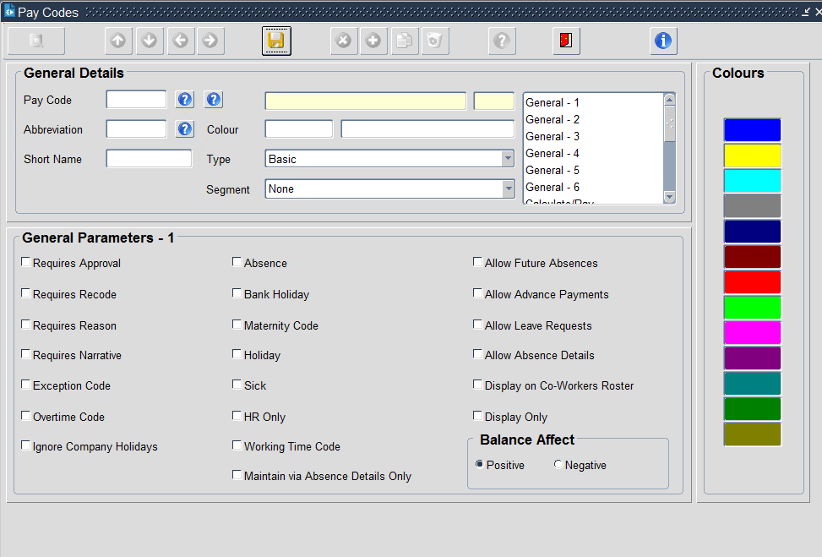
Pay Codes active in Time
Pay Codes not yet active in Time

There are 14 screens of parameters for each pay code. Rather than attempting to detail all of these options, pay codes can be grouped based on their behaviour.

Creating/amending Pay Codes
A series of questions need to be considered when setting up or amending pay codes in Time. Settings can then be copied from existing pay codes before reviewing the test environment.
Add the code to the relevant Pay Code Groups so that employees and managers can record time against it CoreTime/Core Roster > System Params > Reference K-P > Personalised Pay Code Groups
Add to the relevant Working Time Group columns
CoreTime/Core Roster > System Params > Reference Q-Z > Working Time Parameters > Working Time Group 029 > Pay Code Groups button
Create a reason code(s) and add these to a reason code group, or select an existing reason code group and link to the Pay Code CoreTime/Core Roster > System Params > Reference Q-Z > Reason Codes/Reason Code Groups

Sensitive absences should not have ‘Display on Co-Worker’s roster’ ticked on General Parameters 1.
See subcategories

Example 1 – Adding a new absence type
This is an example only, illustrating how to determine which pay code settings to mirror based on the intended code behaviour.

A new University policy introduces a Green Day, where employees can take 1 day off per annum to focus on activities which have a positive impact on the environment.

The code involves taking time off and is therefore a ‘Leave & Absence code’
The code can be added to the ‘Emp Absence’ column, as it isn’t relevant for Sign off.
The benefit is only available to employees with set hours of work, it is added to the Employee Support Staff and Employee Academic-related Pay Code Groupings.
The code will be recorded by the employee’s manager or HR department, as per the subcategory ‘Absence – Basic’
The absence isn’t considered sensitive and can be displayed to colleagues on the Co-Worker’s roster’
No reason is required for this absence, it doesn’t need to be linked to a reason group

Example 2 – Adding a new Casual Pay Code
This is an example only, illustrating how to determine which pay code settings to mirror based on the intended code behaviour.
A new casual pay code has been set up Casual Catering Assistant (HRS).

The absence isn’t considered sensitive and can be displayed to colleagues on the Co-Worker’s roster’
Hours worked against this code cause the casual worker to accrue holiday pay, it therefore falls into the category of Paid as Claimed Work, updating the casual holiday accrual balance
The code can be added to the ‘Emp Absence’ column, as it isn’t relevant for Sign off.
A new Pay Code Grouping would need to be created, Casual Catering Assistant – GL, containing the code and the CAS HOLIDAY PAY (HRS)
No reason is required for this code, it doesn’t need to be linked to a reason group
This is an hourly payment code for casual work, it is pay affecting and is therefore a Timesheet code.

Example 3 – Adding an Employee Request (balance-linked) code
This is an example only, illustrating how to determine which pay code settings to mirror based on the intended code behaviour.
A new absence code is required for research staff to record their development days

The code can be added to the ‘Emp Absence’ column, as it isn’t relevant for Sign off.
The development days are only available to academic-related staff, it is therefore added to the G6+ academic related pay code group.
Employees are asked to categorise the development under one of 3 options, 3 new reason codes are created and new ‘development’ reason code group associated with the pay code.
The absence isn’t considered sensitive and can be displayed to colleagues on the Co-Worker’s roster’
Employees will have up to 10 days per year to use of development activities, which they can request from their manager, it therefore falls into the subcategory ‘Employee Request (balance-linked)’
This will involve employees taking time away from normal duties and is therefore a leave & absence code

Pay codes linked to MSS sign off
Pay Code | Pay Code Ind | Name
107 | A | PAID AS CLAIMED PAYMENT
329 | A | HOLIDAY PAY IN HOURS
4200 | A | ~CAS ADMINISTRATION (HRS)
4201 | A | ~CAS PR ADMINISTRATION (HRS)
4202 | A | ~CAS BAR WORK (HRS)
4203 | A | ~CAS CASUAL LABOUR (HRS)
4204 | A | ~CAS PR CASUAL LABOUR (HRS)
4205 | A | ~CAS CLERICAL ASSIST (HRS)
4206 | A | ~CAS PR CLERICAL ASSIST (HRS)
4207 | A | ~CAS CONSULTANCY (HRS)
4208 | A | ~CAS PR CONSULTANCY (HRS)
4209 | A | ~CAS DEMONSTRATING (HRS)
4210 | A | ~CAS PR DEMONSTRATING (HRS)
4211 | A | ~CAS EXAMINING (HRS)
4212 | A | ~CAS PR EXAMINING (HRS)
4213 | A | ~CAS INVIGILATING (HRS)
4214 | A | ~CAS PR INVIGILATING (HRS)
4215 | A | ~CAS IT ASSISTANT (HRS)
4216 | A | ~CAS PR IT ASSISTANT (HRS)
4217 | A | ~CAS LECTURING (HRS)
4218 | A | ~CAS PR LECTURING (HRS)
4219 | A | ~CAS LIFE MODEL (HRS)
4220 | A | ~CAS PORTERING (HRS)
4221 | A | ~CAS RESEARCH ASSIST (HRS)
4222 | A | ~CAS PR RESEARCH ASSIST (HRS)
4223 | A | ~CAS SHOP ASSISTANCE (HRS)
4224 | A | ~CAS PR SHOP ASSISTANCE (HRS)
4225 | A | ~CAS STUDENT HELP (HRS)
4226 | A | ~CAS PR STUDENT HELP (HRS)
4229 | A | ~CAS TEACHING (HRS)
4230 | A | ~CAS PR TEACHING (HRS)
4231 | A | ~CAS HOLIDAY PAY (HRS)
4232 | A | ~CAS PR HOLIDAY PAY (HRS)

Accrual Balances & Pay Codes
Leave which is accrued is managed through timesheets. For the balance to function correctly and to allow staff to record leave taken, Pay Codes need to be correctly configured. Unlike Entitlement Balances, which share pay codes, it is likely each Accrual Balance will require its own set of Pay Codes including:
- At least one Accrual Pay Code which accrues leave e.g. 107 PAID AS CLAIMED PAYMENT
- At least one Holiday Pay Code which records leave taken e.g. 4231 CAS HOLIDAY PAY (HRS)
Pay Codes should be created before attempting to configure an Accrual Balance. Bespoke Pay Code Access Groups will be required to enable the appropriate staff to record time against these pay codes.

